### **Samsung MS23F301EAK Microwave**

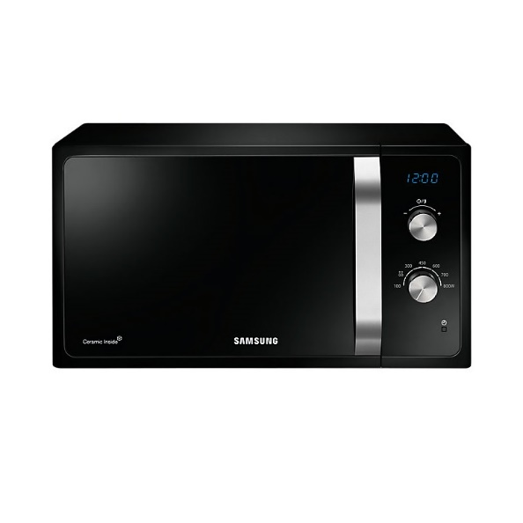

|  |  |
| --- | --- |
| **Capacity(litres):** | 23 |
| **Control System:** | Manual |
| **Grill:** | Yes |
| **Color:** | Silver |
| **Cavity:** | Enamel |
| **Built-in Frame:** | Yes |
| **Net Width x Height x Depth:** | 489 x 275 x 374 |
| **Net Weight:** | 12 |
| **Nominal Power Microwave:** | 1150W |
| **Nominal Power grill:** | 1200W |
| **Microwave Power Levels:** | 7 |
| **Convection function:** | No |
| **Child Safely Lock:** | Yes |